Protein Function

In previous classes, we have know that the functions of protein are determined by the structure and conformation of proteins, proteins with different structural will function differently, and also, even with same structure but different conformation, the protein might show different function, such as before and after the denaturation.
Proteins, according to their functions, can be divided into different categories, such as enzymes, transport proteins, motor proteins, regulatory proteins, immunoglobulins, and some fibrous proteins such as a-keratin, collagen and silk fibroin.
Enzyme is a kind of specific protein, which shows the ability to accelerate chemical reactions, where the chemical acted upon by enzymes are called reaction substrate or simply substrate instead of using ligand, and the binding site is called the catalytic site or active site. We will focus on normal protein in this chapter.
For the normal proteins, they can bind some kind of molecules reversibly, and these kinds of molecules are called ligands. The ligand might be any kind of molecules, even a protein, but for a particular protein, the number of ligand is restricted. A ligand binds at a site on the protein called the binding site, which is complementary to the ligand in size, shape, charge, and hydrophobic or hydrophilic character. This is why the number of ligands that can bind to a particular protein is limited. Essentially, after binding with ligand, the conformation of protein is modified to another conformation that is more adaptable for the ligand; in other words, after the bind, the conformation of protein is adjusted to be more complementary to the ligand, permitting tighter binding. This kind of structure adaptation that occurs between protein and ligand is called induced fit. (Note: for the multisubunit protein, a conformational change in one subunit often affects the conformation of other subunits. Like the transport protein on the cell surface, when one ligand bind to a subunit of protein, and will trigger the protein to form a channel and let some kind of metal ion to pass through).

Reversible binding of a protein to a ligand: oxygen-binding proteins
Oxygen binding protein includes myoglobin and hemoglobin.
Oxygen can be bound to a heme prosthetic group
Oxygen is very important to the aerobic cells, however, as oxygen is nonpolar molecule, it has very low solubility in aqueous solution, such as in blood. So, oxygen cannot deliver into deep inside of cell by simple diffusion, and oxygen cannot migrate in tissue for a long distance either. The transportation of oxygen in animal is performed by hemoglobin, a protein in erythrocyte. However, none of the side chains for amino acid within the protein can bind oxygen strong enough, either polar or nonpolar side chains. The reason is the polar side chain cannot form strong interaction with nonpolar oxygen; on the other hand, the nonpolar side chain cannot form strong interaction with oxygen either, because any kind of weak interaction such as hydrogen bond, van der Waals or hydrophobic interaction are very weak though. To complement this disadvantage, protein adopts a prosthetic group called heme. (A prosthetic group is a compound permanently associated with a protein that contributes to the protein’s function). Heme (or haem) consists of a complex organic ring structure, protoporphyrin IX, to which is bound a single iron atom in its ferrous (Fe²⁺) state. Porphyrins, of which protoporphyrin IX is only one example, consist of four pyrrole rings linked by methane bridges, with substitutions at one or more of the positions denoted X. The iron atom has six coordination bonds, four to nitrogen atoms from porphyrin ring, and two perpendicular to the porphyrin. Beside iron atom, copper atom can bind with porphyrin ring also.

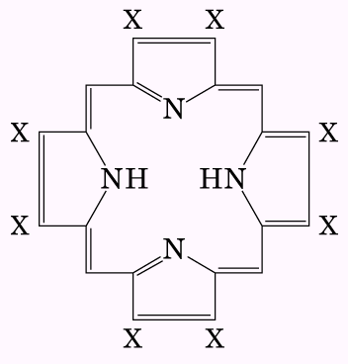  Structure of Porphyrin | 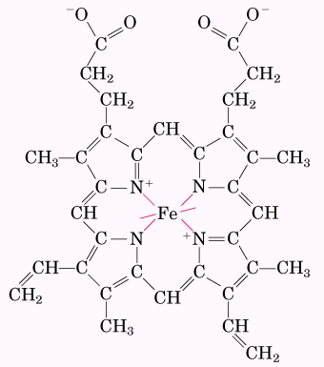  Structure of heme

The coordination of nitrogen to ferrous ion in heme has two folds of roles. First of all, the coordination with nitrogen prevents the ferrous ion from oxidizing into ferric ion; this process in solution can change oxygen to very reactive hydroperoxide or hydroxyl radical. It is know that radical in cell is very dangerous to DNA or other biomolecules. Secondly, coordinated ferrous ion can bind oxygen reversibly, and ferric ion cannot bind oxygen.

Besides the binding of oxygen with ferrous ion in heme, other molecules, which form d-π interaction with ferrous ion, can bind with ferrous ion also. These kind of molecules include CO, NO, CN⁻, because the d-π interaction is stronger than the coordination between ferrous ion and oxygen, these molecules or ion can bind extremely tight with heme, for example, CO bind 20,000 times more stronger than oxygen. This is why these molecules are very toxic to aerobic cells.

Myoglobin has a single binding site for oxygen
As mentioned in previous chapter, myoglobin (Mb) is a relative small protein with MW of 16,700 (about 153 amino acid residues); it is a globular protein, with 8 α helices connected by bends. About 78% of amino acid residues are found on helices. The 8 helices are in different size, the largest one contains 23 amino acid residues, and the smallest one contains only 7 residues. These helices are detonated as A, B, C, until H segments, between these segments, the bends are called AB, CD, and so forth. Remember, there are not bends between helix B and C, and also between D and E. In myoglobin, ferrous ion bind with four nitrogen atoms from porphyrin, and also with another nitrogen atom from the Histine side chain at position 93, called His⁹³. Because this amino acid is located at 8th amino acid residues on helix F, it is also call F8. This nitrogen is closest one towards ferrous besides the four nitrogen atoms from porphyrin ring, therefore, it is called proximal His. Besides this histine, there is another histine residue stays as 7th amino acid in helix E, and overall is 64th amino acid in myoglobin, so it is called His⁶⁴ or His E7. This amino acid also plays some role during the binding of oxygen with heme. When oxygen binds with heme, the oxygen molecule is tilted an angle against the porphyrin ring, and His⁶⁴ does not hinder the binding of heme with oxygen, however, for molecules such as CO and NO, they can form strongest binding with heme only when they are perpendicular to heme ring, it is because of His⁶⁴, these molecules are forced to bind with heme in tilted states, and the binding strength is reduced. Under this circumstance, the binding with CO is not that much preferred over oxygen, otherwise, even lower concentration of CO will prevent the binding of oxygen, and this condition is easy to meet under biological condition.
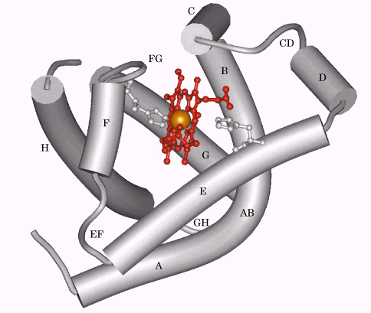
The structure of protein myoglobin

Protein-ligand interactions can be described quantitatively
The reversible binding of a protein (P) to a ligand (L) can be represented by the equilibrium:
So, we will have: $\text{Ka}=\frac{[\text{PL}]}{[P][L]}$ (1)
Ka is the association constant; make sure this Ka is totally different from the Ka used in acid and base.
From equation (1), we can have: $\text{Ka}[L]=\frac{[\text{PL}]}{[P]}$ (2)
Equation (2) is equivalent to equation (3)
[PL] = Ka[L][P] (3)
Here we define a term θ (theta), a fraction of ligand-binding sites over the total available binding site on the protein. So:
$θ=\frac{\text{binding}\begin{matrix} & \begin{matrix}\text{sites} & \text{occupied}\end{matrix}\end{matrix}}{\begin{matrix}\text{total} & \text{binding} & \text{sites}\end{matrix}}=\frac{[\text{PL}]}{[\text{PL}]+[[P]}$ (4)
From equation (3) and (4), we can have equation (5)
$θ=\frac{\text{Ka}[L][P]}{\text{Ka}[L][P]+[P]}=\frac{\text{Ka}[L]}{\text{Ka}[L]+1}=\frac{[L]}{[L]+\frac{1}{\text{Ka}}}$ (5)
Alternatively, we can use term of dissociation constant, Kd, which is the reciprocal of Ka (Kd = 1/Ka) and is given in units of molar concentration (M). Kd is the equilibrium constant for the release of ligand. So we have:
$θ=\frac{[L]}{[L]+\text{Kd}}$ (6)
When [L] is equal to Kd, half of the ligand-binding sites are occupied. When [L] is lower than Kd, little ligand binds to the protein. So, Kd is the molar concentration of ligand at which half of the available ligand-binding sites are occupied. At this point, the protein is said to have reached half saturation with respect to ligand binding. The more tightly a protein binds a ligand, the lower the concentration of ligand required for half the binding sites to be occupied, and thus the lower value of Kd.
For the case of binding oxygen to myoglobin, as the concentration of oxygen in solution is always proportional to its partial pressure in the gas phase above the solution, so, experimentally, we can use the partial pressure of oxygen to substitute [O₂], and we can have equation (7), where the partial pressure of oxygen at half binding as P₅₀.
$θ=\frac{{\text{pO}}_{2}}{{\text{pO}}_{2}+P_{\text{50}}}$ (7)
According to equation (6) and (7), we can measure the hyperbola curve during the binding as shown follows.
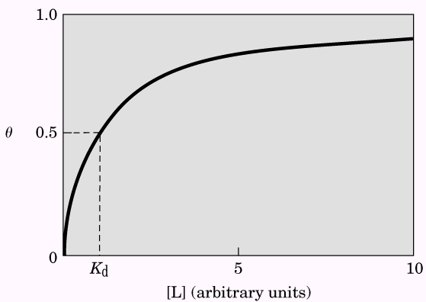  Graphical representation of ligand binding | 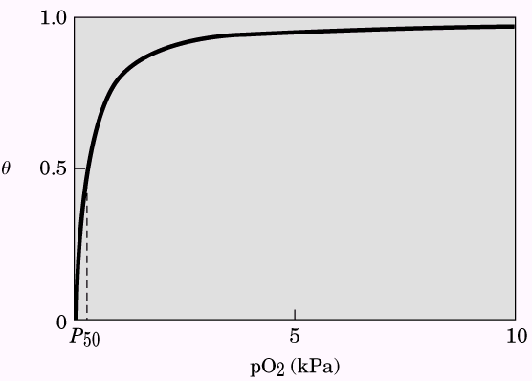  A curve describing the binding of oxygen to myoglobin

Table 1 listed some of the dissociation constant of proteins with their ligands.
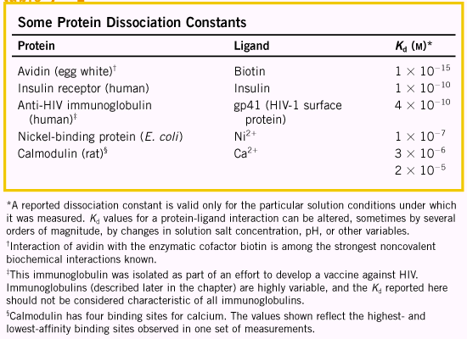
Oxygen is transported in blood by hemoglobin
Hemoglobin (Hb) is a protein in erythrocyte, with molecular weight of 64,500, it is a protomer with two αβ units, that means hemoglobin consists of four subunits, i.e., two α subunits (141 residues each), and two β subunits (146 residues each). Although less than half of peptide sequence are identical between α and β chain, their three-dimensional structures are very similar; in addition, their structures are very similar to that of myoglobin, unless the α chain lacks the short D helix. Shown follows is the comparison of three-dimensional structure between myoglobin and β chain of hemoglobin.

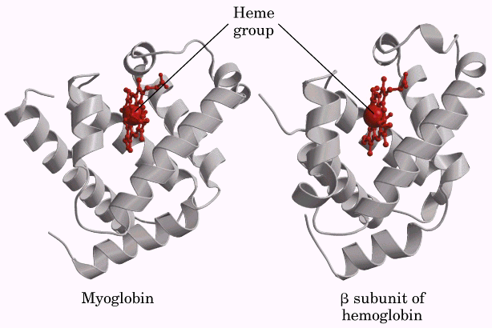
The comparison of the structure of myoglobin and the β chain of hemoglobin

Because hemoglobin has four subunits, it contains for heme groups and can bind four oxygen molecules. Hemoglobin is the major component of erythrocyte (red blood cell). Erythrocyte with diameter of 6 to 9 μm, is biconcave disk without intracellular organelles such as nucleus, mitochondria and ER. Erythrocyte passes through lung and binds oxygen, and releases oxygen at tissues. Each 100 mL of blood passing through a tissue release about one-third of the oxygen it carries, or 6.5 mL oxygen gas at atmospheric pressure and body temperature.

Hemoglobin undergoes a structural change on binding oxygen
X-ray analysis has revealed two major conformations of hemoglobin: the R state and the T state. R and T originally denoted “tense” and “relaxed” respectively, because the T state is stabilized by a greater number of ion pairs, many of which lie at the α₁β₂ (and α₂β₁) interface. So, hemoglobin binds oxygen preferentially at R states. When oxygen is absent experimentally, T state is more stable and thus the predominant conformation of deoxyhemoglobin.

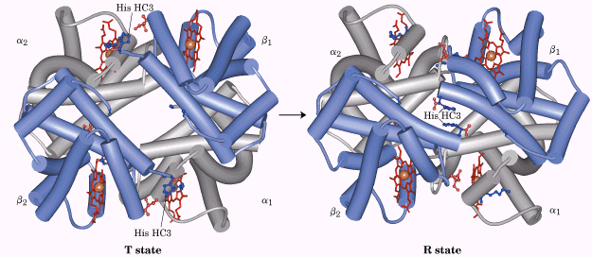  The T →R transition | 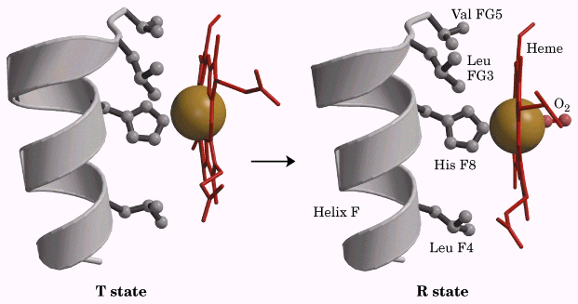  Changes in conformation near heme on O2 binding

Hemoglobin binds oxygen cooperatively
Hemoglobin is evolved to bind oxygen efficiently at lung, and release oxygen at tissue, where the binding with oxygen is reduced. This property with hemoglobin is very important, and is why hemoglobin can transport oxygen. Hemoglobin solves the problem by undergoing a transition from a low-affinity state (the T state) to a high-affinity state (the R state) as more oxygen molecules are bound. When oxygen binds to individual subunit of hemoglobin, it can alter the affinity for oxygen in adjacent subunits. The first molecule of oxygen that interacts with deoxyhemoglobin binds weakly, once it binds, the conformation changes and makes hemoglobin easier for the additional oxygen to bind.
Hemoglobin has four subunits, belongs to a group of proteins called allosteric protein, which is a kind of protein when the binding of a ligand to one site affects the binding properties of another site on the same protein. The conformational changes induced by the modulator interconvert more-active and less-active forms of the protein. When the normal ligand and modulator are identical, the interaction is termed homotropic; when the modulator is a molecule other than the normal ligand, the interaction is heterotropic. Remember the difference with heterotroph.
A sigmoid bonding curve is diagnostic of cooperative binding.
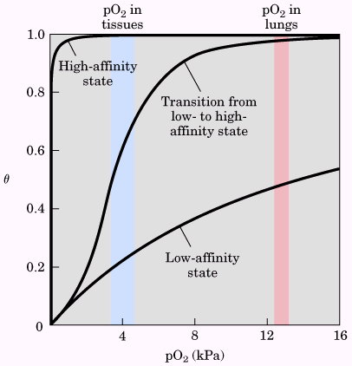  A sigmoid (cooperative) binding curve | 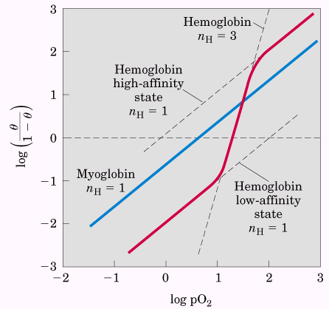  Hill plots for the binding of oxygen to myoglobin and hemoglobin.

Cooperative ligand binding can be described quantitatively
Similar to the quantitatively description of the binding of myoglobin, the binding of hemoglobin with oxygen can be described quantitatively also.
$θ=\frac{[L]^{n}}{[L]^{n}+K_{d}}$ (8)
$\frac{θ}{1−θ}=\frac{[L]^{n}}{K_{d}}$ (9)
$\text{log}\left(\frac{θ}{1−θ}\right)=n\text{log}[L]−\text{log}K_{d}$ (10)
Equation (10) is called Hill equation, and a plot of $\text{log}\left(\frac{θ}{1−θ}\right)$ versus log[L] is called a Hill plot. According to equation (10), the Hill plot should have a slope of n, however, the experimentally determined slope actually reflects not the number of binding sites, but the degree of interaction between them. The slope of a Hill plot is therefore denoted n_{H}, the Hill coefficient, which is a measure of the degree of cooperativity. For the case of binding oxygen, again the partial pressure of oxygen is more practical for the experiment.
$\text{log}\left(\frac{θ}{1−θ}\right)=n\text{log}{\text{pO}}_{2}−\text{log}P_{\text{50}}$ (11)

Hemoglobin also transport H⁺ and CO₂
In addition to carrying nearly all the oxygen required by cells from the lungs to the tissues, hemoglobin carries two end products of cellular respiration H⁺ and CO₂ from the tissues to the lungs and the kidneys, where they are excreted. The enzyme catalyze the hydration of CO₂ is called carbonic anhydrase, and this enzyme is particularly abundant in erythrocytes. The binding of oxygen by hemoglobin is profoundly influenced by pH and CO₂ concentration, at the relatively low pH and high CO₂ concentration of peripheral tissues, the affinity of hemoglobin for oxygen decreases as H⁺ and CO₂ are bound, and O₂ is released to the tissues. Conversely, in the capillaries of the lung, as CO₂ is excreted and the blood pH consequently rises, the affinity of hemoglobin for oxygen increases and the protein binds more O₂ for transport to the peripheral tissues. This kind of effect is called Bohr effect. Remember the binding sites to oxygen and H⁺ or CO₂ are different.

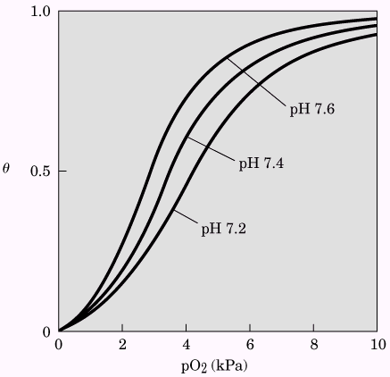  Effect of pH on the binding of oxygen to hemoglobin | 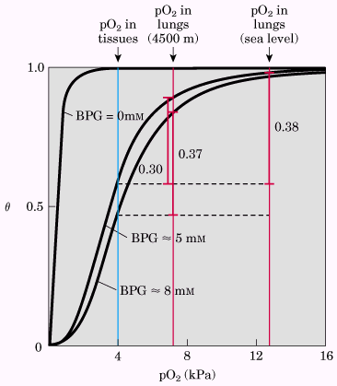  Effect of BPG on the binding of oxygen to hemoglobin

Oxygen binding to hemoglobin is regulated by 2,3-bisphosphoglycerate
2,3-Bisphosphoglycerate (BPG) is present in relatively high concentration in erythrocytes. BPG is known to greatly reduce the affinity of hemoglobin for oxygen; there is an inverse relationship between the binding of O₂ and the binding of BPG. BPG binds to hemoglobin in the cavity between the β subunits in the T state; this cavity is lined with positively charged amino acid residues that interact with the negatively charged groups of BPG. There is only one binding site for BPG in hemoglobin.

Sickle-cell anemia is a molecular disease of hemoglobin
The erythrocytes in sickle-cell anemia patient are fewer and also abnormal. In addition to an unusually large number of immature cells, the blood contains many long, thin, crescent-shaped erythrocytes that look like the blade of a sickle. The hemoglobin in sickle-cell anemia is insoluble once deoxygenated, and tends to aggregate and form polymer, which might block the capillary. The altered properties of hemoglobin S result from a single amino acid substitution, a Val instead of a Glu residue at position 6 in the two β chains. The R group of Val has no electric charge, whereas Glu has a negative charge at pH 7.4.

Complementary interactions between proteins and ligands: the immune system and immunoglobulins

The immune response features a specialized array of cells and proteins
Terms:
Leukocytes: white blood cells
Immune system: A complex system of cellular and molecular components having the primary function of distinguishing self from not self and defense against foreign organisms or substances; the primary cellular components are lymphocytes and macrophages, and the primary molecular components are antibodies and lymphokines.
Immune response: Any response of the immune system to an antigenic stimulus, including antibody production, cell-mediated immunity, and immunological tolerance.
Immunity: The condition of being immune; the protection against infectious disease conferred either by the immune response generated by immunization or previous infection or by other nonimmunologic factors
Lymphocyte: Any of the mononuclear, nonphagocytic leukocytes, found in the blood, lymph, and lymphoid tissues. They are divided on the basis of ontogeny and function into two classes, B and T lymphocytes, responsible for humoral and cellular immunity, respectively.
Macrophage: Any of the many forms of mononuclear phagocytes found in tissues. Most macrophages are large cells with a round or indented nucleus, a well-developed Golgi apparatus, abundant endocytotic vacuoles, lysosomes, and phagolysosomes, and a plasma membrane covered with ruffles or microvilli.
Antibody: An immunoglobulin molecule that has a specific amino acid sequence by virtue of which it interacts only with the antigen that induced its synthesis in cells of the lymphoid series.
Lymphokine: A general term for soluble mediators of immune responses that are not antibodies or complement components and that are released by sensitized lymphocytes on contact with antigen.
Complement system: The functionally related system comprising at least 20 distinct serum proteins that is the effector not only of immune cytolysis but also of other biologic functions. Referred to simply as complement.
Immunoassay: any of several methods for the quantitative determination of chemical substances that utilize the highly specific binding between an antigen or hapten and homologous antibodies, including radioimmunoassay, enzyme immunoassay, and fluoroimmunoassay.
Immunoblots: A technique for, or the blots resulting from, analyzing or identifying proteins via antigen-antibody specific reactions, as in Western blot or dot blot techniques.
Immunodeficiency: A deficiency of immune response or a disorder characterized by deficient immune response; classified as antibody (B cell), cellular (T cell), combined deficiency, or phagocytic dysfunction disorders.
Immunoglobulins: Proteins found in the blood serum and in tissue fluids, also known as antibodies. Immunoglobulins are produced by cells of the immune system called B-lymphocytes. Their function is to bind to substances in the body that are recognized as foreign antigens (often proteins on the surface of bacteria and viruses). This binding is a crucial event in the destruction of the microorganisms that bear the antigens. Immunoglobulins also play a central role in allergies and hypersensitivity reactions. In this case they bind to antigens that are not necessarily a threat to health, which may provide an inflammatory reaction. There are five classes of immunoglobulins; of these, immunoglobulin G (IgG) is the major immunoglobulin in blood serum.
IgG immunoglobulin - The IgG molecule consists of two parts, one of which binds to antigen; the other binds to other cells of the immune system. These other cells are principally white cells called phagocytes, which then engulf the microorganisms bearing the antigen. The antigen-binding site of the IgG molecule is variable in its structure, the different versions of the molecule being capable of binding to an almost infinite number of antigens.
Immunosuppression: The prevention or diminution of the immune response, as by irradiation or by administration of antimetabolites, antilymphocyte serum, or specific antibody; called also immunodepression.
Hapten: A small molecule, not antigenic by itself, that can react with antibodies of appropriate specificity and elicit the formation of such antibodies when conjugated to a larger antigenic molecule, usually a protein, called in this context the carrier or schlepper. Antibody production involves activation of B-lymphocytes by the hapten and helper T lymphocytes by the carrier.
CD4 (T4): A protein embedded in the cell surface of helper T-lymphocytes; also found to a lesser degree on the surface of monocyte/macrophage, langerhans cells, astrocytes, keratinocytes, and glial cells. One of the ways HIV invades cells is by first attaching to the CD4 molecule (CD4 receptor).
CD4 Cell: “Helper” T-cell, responsible for coordinating much of the immune response. CD4 cells are one of the main targets damaged by HIV.
CD4 Count: The number of T-helper lymphocytes per cubic millimeter of blood. The CD4 count is a good predictor of immune health. A CD4 count less than 200 qualifies as a diagnosis of AIDS.
CD8 (T8): A protein embedded in the cell surface of killer and suppresser T-lymphocytes.
Cell-Mediated Immunity (CMI): A branch of the immune system responsible for the reaction to foreign material by specific defense cells (T-lymphocytes, killer cells, macrophage and other white blood cells) rather than antibodies.
Humoral Immunity: The branch of the immune system that relies primarily upon antibodies.
Antigen: Any substance that antagonizes or stimulates the immune system to produce antibodies, proteins that fight antigens. Antigens are often foreign substances such as bacteria or viruses that invade the body.
Epitope: A unique shape or marker carried on an antigen's surface, which triggers a corresponding antibody response.
Major Histocompatibility Complex (MHC): Two classes of molecules of the surfaces of antigen presenting cells. Antigen is complexed with MCH MHC II, or I and presented to an effector cell. Antigen without MHC is ignored. Discordant MHC type is the source of graft versus host disease and other rejection phenomena. MHC Class I is used for presentation to CD8 cells. Class II is used to present antigen to CD4 cells.
Antigen Presenting Cell (APC): A white blood cell that devours foreign bodies, breaks them down, and carries characteristic antigen peptides to it's surface. The foreign antigen, complexed with MHC I or II is presented to CD4 or CD8 to initiate an immune response specific to that peptide.
T Cells (T lymphocytes): A thymus-derived white blood cell that precipitates a variety of cell mediated immune reactions. Three fundamentally different types of T cells are recognized: helper, killer, and suppresser (each has many subdivisions).
T Helper Cells: Lymphocytes responsible for assisting other white blood cells in responding to infection, processing antigen, and triggering antibody production (also known as T4 cells, CD4 cells).
T Killer Cells: A major component of cytotoxic lymphocyte response (CTL), responsible for lysing infected or cancerous cells, T killer cells (not to be confused by natural killer cells) are a subset of CD8⁺ lymphocytes.
T Suppresser Cells: T lymphocytes responsible for turning the immune response off after infection is cleared, a subset of CD8⁺ lymphocytes.

Our human can live health, because we have our immune system. The immune systems has two primary functions: (1) recognition of and defense against foreign substances and (2) immunosurveillance. When foreign substances such as bacteria, viruses, fungi, or parasites are introduced into a vertebrate host, the host either (1) nonspecifically clears the infectious agent using preformed components or (2) produces specific cells and molecules directed against the foreign invader. The latter response is traditionally called an immune response. We have two levels of immunities, innate immunity and acquired immunity. Innate immunity (natural resistance) operates nonspecifically during the early phases of an immune response, which serves as the first line of defense and includes both external and internal nonspecific responses. External defenses occur in those areas of the body exposed to the outside environment (skin, body secretion, and mucous membranes); internal defenses come into play when the pathogen has penetrated the external defenses, internal innate immunity includes three general mechanisms (physiologic barriers, phagocytosis, and inflammation). Taken together, the components of innate immunity are preformed (the components are present before challenge), standardized (the response magnitude is consistent), without memory (the host does not realize it has been reexposed to the same invader) and nonspecific (innate immunity does not distinguish between invaders). An organism’s innate immunity depends on its species, race or strain and sex.

Because microorganisms evolve rapidly, they can devise ways to evade the standardized innate immune responses of slower-evolving hosts. Vertebrates use an additional immune recognition strategy called acquired, or adaptive or specific immunity. Acquired immunity permits the host to recognize and respond to a specific invader, even without prior exposure and is marked by an enhanced response on repeated exposures to the invader. Acquired immunity develops during a host’s lifetime and is based partly on the host’s experiences. This exposure process is called immunization. Acquired immunity is the surveillance mechanism of vertebrates that specifically recognizes foreign antigens and selectively eliminates them, and on reencountering the antigens has an enhanced response. It has six major characters: specificity, inducibility, diversity, memory, distinguishing self from nonself, and self-limiting. Acquired immunity can be either humoral or cell-mediated, or both. Humoral immunity is mediated by antigen-specific blood proteins called antibodies, which are secreted only by plasma cells (B cells), this immunity protects against circulating extracellular antigens such as bacteria, microbial exotoxins, and viruses in their extracellular phase, that is antibodies normally interact with circulating antigens but are unable to penetrate living cells. Cell-mediated immunity is mediated by antigen-specific cells called thymus-derived or T, lymphocytes, which contain two subpopulations, T helper cells (Th1 and Th2), and T cytotoxic (Tc) cells. On the other hand, acquired immunity can be active or passive. Active immunity is acquired gradually (5 to 14 days after antigen exposure), lasts for years, and is highly protective. Passive immunity is immediate, lasts for days to months, has low to moderate protective effectiveness, and does not develop memory in the recipient. Both active and passive immunity can be further subdivided into natural and artificial forms.

If an individual is exposed to foreign substances naturally through the environment, rather than by immunization with a vaccine, that individual acquires the natural rather than the artificial form of active immunity. In passive immunity, an individual has acquired immunity mediated by antibodies (or sensitized T cells) formed in another individual.

Antigens are macromolecules (MW 10,000) that possess a high degree of internal chemical complexity. They are soluble in water and foreign to the animal in which they stimulate antibodies. We generally do not produce antibodies against our own body’s molecules or against low-molecular-weight molecules (less than 10,000). Antigen must be foreign to the host, and soluble in body fluids. Hapten are low molecular weight molecules that are non-antigenic and cannot stimulate antibody production by themselves, however, by conjugation to larger carrier molecules, they can be made antigenic. Antibodies produced in this matter will react specifically with low molecular weight haptens.

Immune response also includes the involvement of MHC and APC, APC will present MHC on their surface, and MHC includes class I MHC, class II MHC and class III MHC. Class I MHC always associates with CD8 cell (or CTL), and class II MHC always associate with CD4 cells (T4 cells, or T helpers).
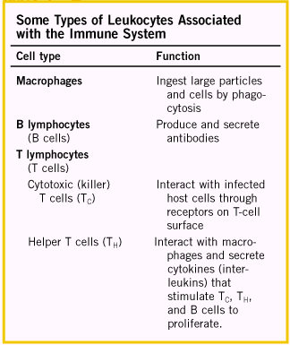 | 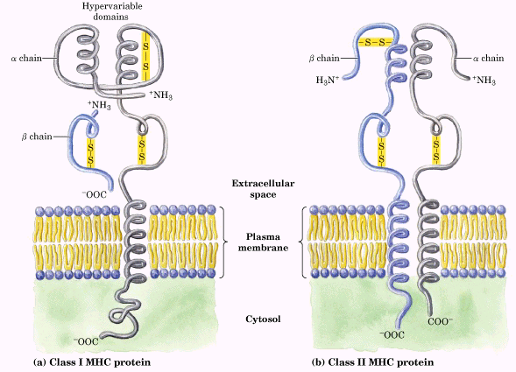  Graphical illustration of MHC proteins

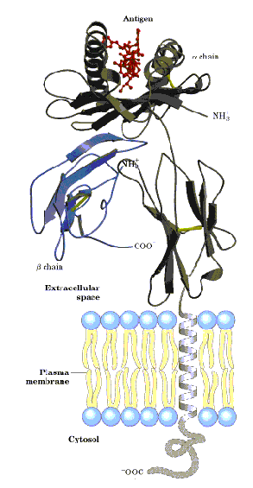

Structure of a human class I MHC protein

In humoral immunity, antibody is involved. An antibody immunoglobulin is a "Y" shaped molecule made up of two identical "light" and "heavy" chains of amino acids. The variable region includes the N-terminal 110-130 amino acids of the light and heavy chains, and is responsible for binding to antigen. The constant region is the C-terminal end and contains similar amino acids for each class of antibody. Light chains may be λ or κ. The five major classes of heavy chain are IgM, IgG, IgA, IgD, and IgE. Each of these classes differs in their locations in our body and how they stimulate the innate system to remove antigen. The immune system creates billions of different antibodies with a limited number of genes by rearranging DNA segments during B cell development, prior to antigen exposure. Mutation can also increase genetic variation in antibodies.

When a stem cell changes to become a B cell, DNA segments for both heavy (VDJ) and light (VJ) chains are randomly combined. Each B cell ends up with functional genes for making one light and one heavy chain coding for an antibody as a membrane-bound receptor. Antibody specificity depends on the gene fragments used. Antibodies are produced that can react with almost any chemical structure in nature, including our own proteins.
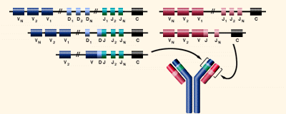 | 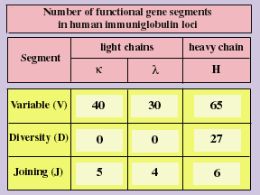

Over 15,000,000 combinations of Variable, Diversity and Joining gene segments are possible. Imprecise recombination and mutation increase the variability into billions of possible combination.
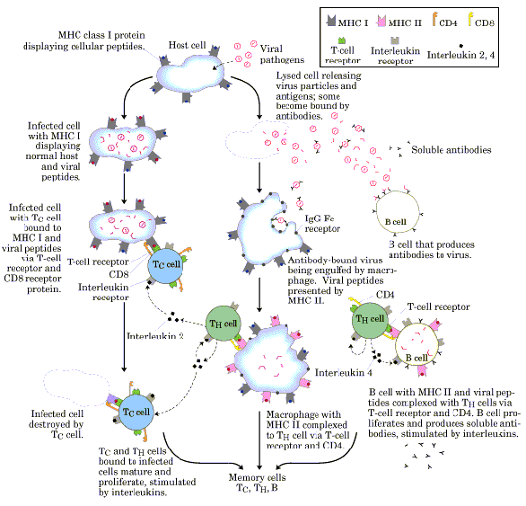
Overview of the immune response to a viral infection

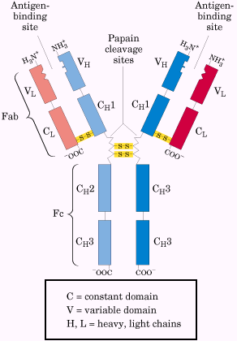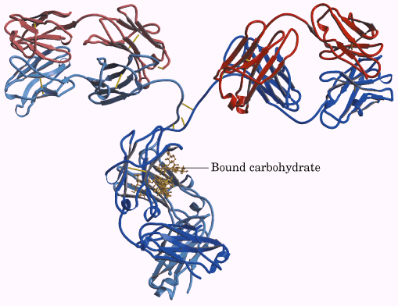
The structure of immunoglobulins G (IgG)

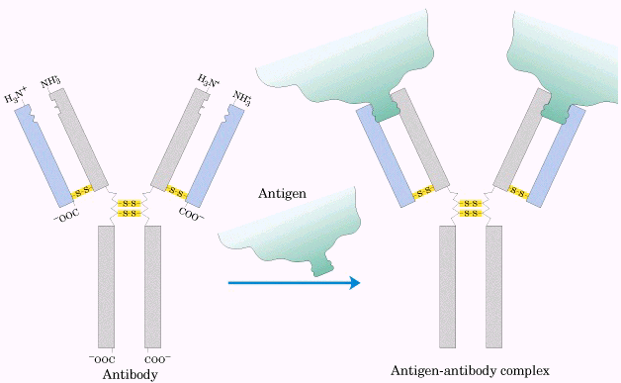  Binding of IgG to an antigen | 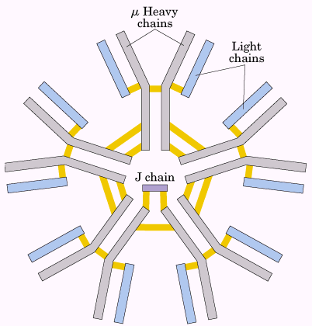  IgM pentamer of immunoglobulins units
The role of antibodies
Type of antibody | Known action
IgG | Phagocytosis, neutralize toxins
IgM | Agglutination and lysis of microbes
IgD | Promote activation of B cells
IgE | Allergic reaction
IgA | Levels affected by stress

An ELISA (enzyme-linked immunosorbent assay) allows for rapid screening and quantification of the presence of an antigen in a sample. Immunoblot assay allows the detection of a minor component in a sample and provides an approximation of its molecular weight.
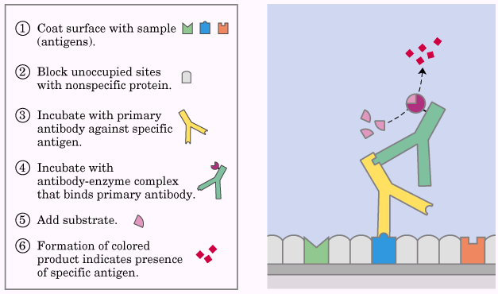  The binding of antibody | 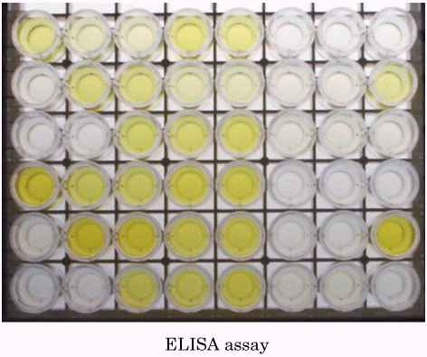 | 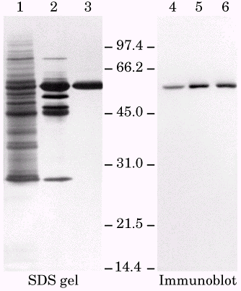

Protein interactions modulated by chemical energy: actin, myosin, and molecular motors
Organelles and macromolecules within cells move. Most of these movements arise from the activity of the fascinating class of protein-based molecular motors.
The major proteins of muscle are myosin and actin
Myosin (Mr 540,000) has six subunits: two heavy chains (Mr 220,000) and four light chains (Mr 20,000). In muscle cells, molecules of myosin aggregate to form structures called thick filaments.
Actin is abundant in almost all eukaryotic cells, in muscle, molecules of monomeric actin, called G-actin (Mr 42,000), associate to form a long polymer called F-actin. The thin filament consists of F-actin, along with the proteins troponin and tropomyosin.

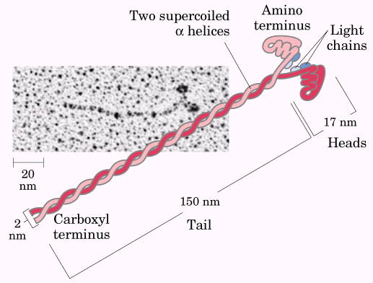  (a) | 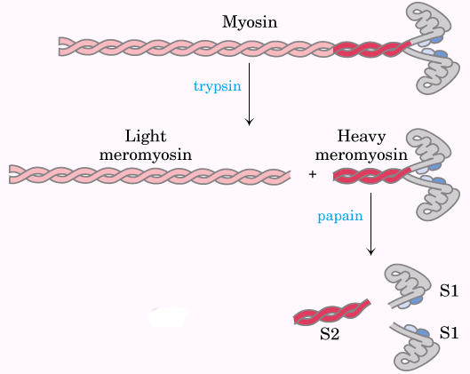  (b) | 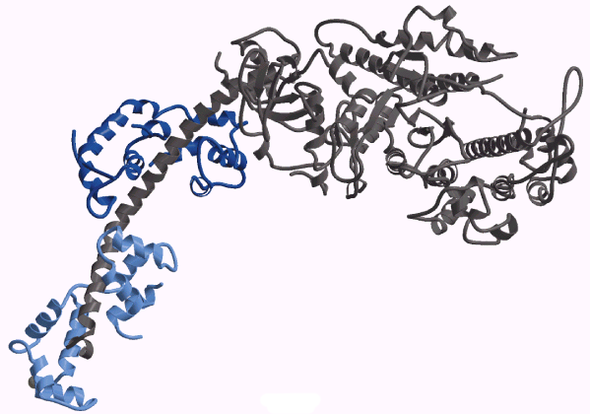  (c)
Structure of myosin: (a) myosin has two heavy chains, the carboxyl termini forming an extended coiled coil (tail) and the amino termini having globular domains (heads), two light chains are associated with each myosin head; (b) cleavage with trypsin and papain separates the myosin heads (S1 fragments) from the tails; (c) ribbon representation of the myosin S1 fragment.

